TOP OF THE RANGE

LASER STIMULATOR + ACUPUNCTURE POINTS SCANNER + ELECTRO ACUPUNCTURE TREATMENT (POINTER PULSE)
FEATURES:
- Modern Spring Type Probe Tip
- Sensitivity Adjustment
- Immediate Point Location and Treatment
- T.E.N.S. Stimulation and or
- Laser stimulation continuous or
- 10 Hz pulsed laser stimulation
TECHNICAL SPECIFICATIONS :
For Electric stimulation
Output Current: 2-45 mA r.m.s.
Pulse Rate: 10 Hz (Fixed) ¡Ó20%
Pulse Width: 260 £gS (Fixed) ¡Ó20%
For Laser stimulation
Laser wavelength: 650nm
Maximum power output: <5mW, solid state diode
¡§I¡¨ : continuous laser output.
¡§II¡¨ : 10 Hz pulsed laser output
Power Source: 9V alkaline battery.
Unit Dimensions: 210 x 45-85 x 24 mm
Unit Weight: 100 gm (unit only).
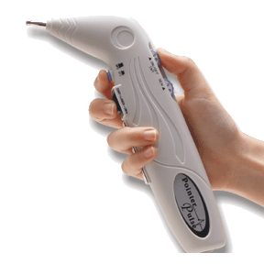
€ 315

ACUPUNCTURE POINTS SCANNER
+ ELECTRO ACUPUNCTURE TREATMENT
(Pointer Excel II)
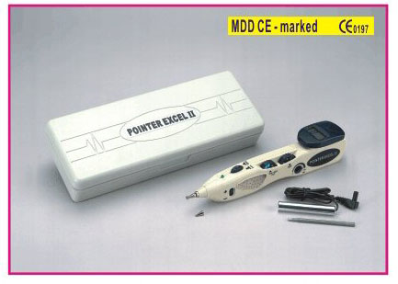
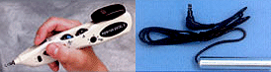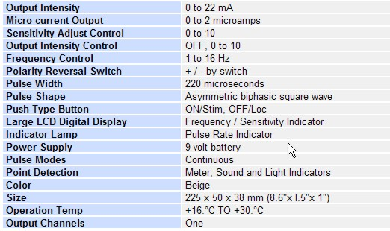
€ 175

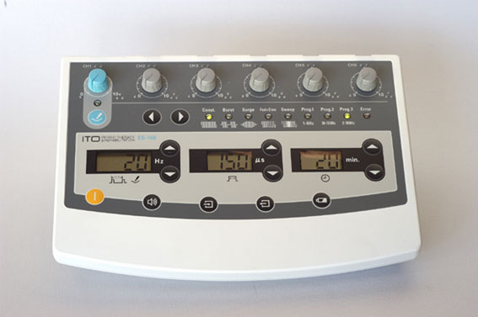
6-Channel Programmable Electro- Acupuncture Device (Model ES-160)
Power supply | DC 6V , four(4) alkaline LR 14 batteries
Number of channels | 6, independently controllable
Pulse shape | Symmetric bi-phase rectangular pulse
Current amplitude | Stimulation by pen type electrode: 0-48 mA(peak)
Electro-acupuncture | High:0-32 mA¡Ó 25%(peak)  Low:0-16 mA¡Ó 25%(peak)
Phase duration | 50-400 ms, adjustable
Timer | 1-60 minutes

€ 585

Professional Acupuncture Apparatus
(Model 6805A-II)

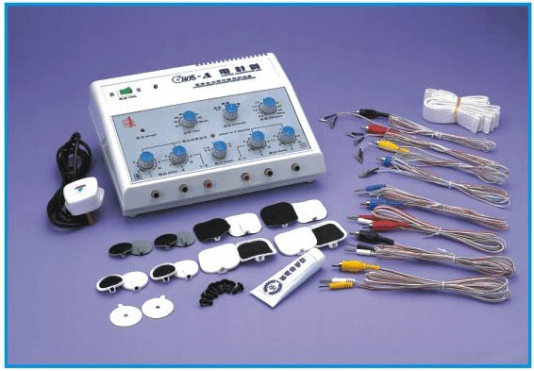
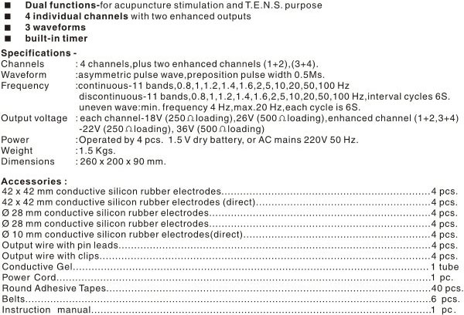
€ 325

Palm-sized Acupuncture Apparatus (Model IC-1107)

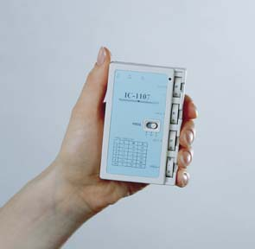
Pulse rate | 0-500 pps. Variable
Intensity | Low setting : max 20 mA High setting : 30 mA (1000 ohms test load)
Pulse width | 100 microseconds
Pulse shape | bi- phasic
Output | 3 channels
Others | Battery checker. Pulse rate indication
Power Source | one 9V battery
Size | 61 x 96x27 mm
Weight : | 200 gm
€ 275

Multipurpose Health Device (Model G6805-2)

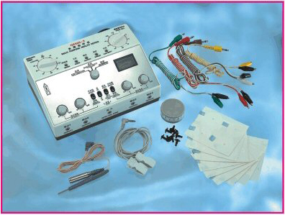
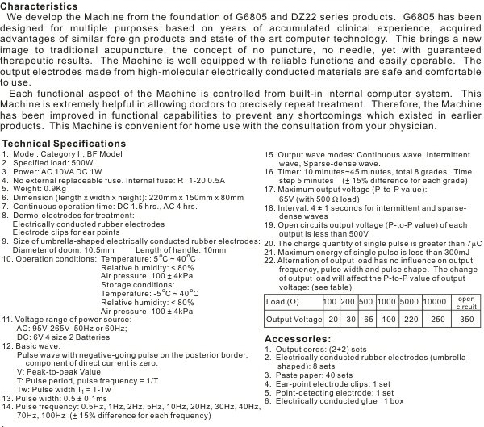
€ 325

Multi-Purpose Health Device (Model KWD-808 II)
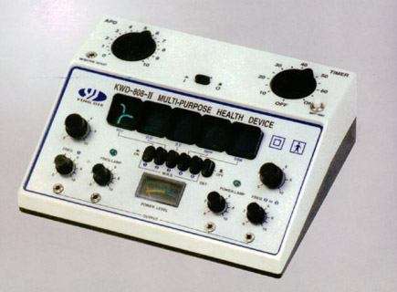
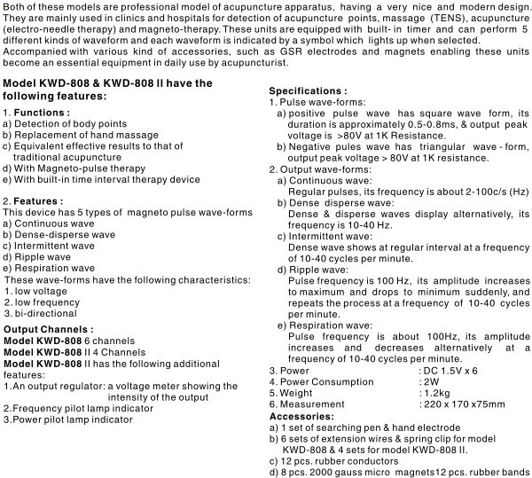
€ 215

Electronic Acupuncture Treatment Instrument
(Model SDZ-II)

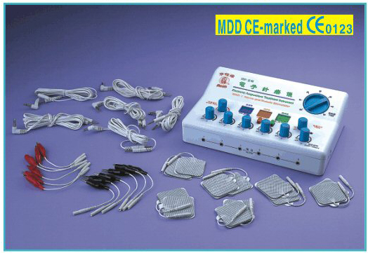
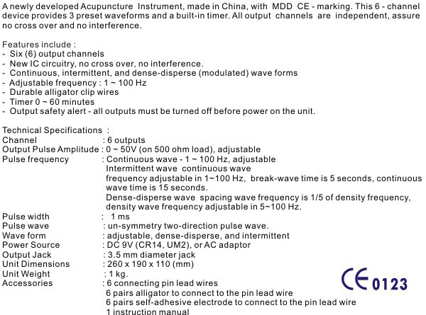
€ 325

Pocket size infra-red Mini Laser

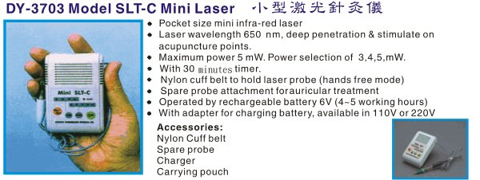

€ 315

Computer And Random Pulse Acupuncture Treatment Instrument (Nerve & Muscle Stimulator)
(Model SMY-10A)

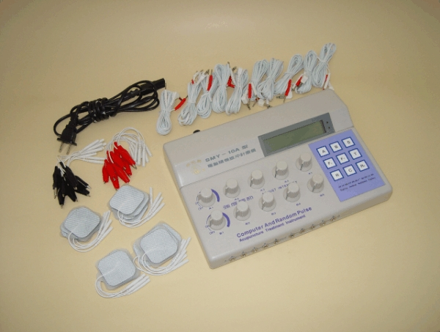
SMY-10A COMPUTER Acupuncture Treatment Instrument is combined with modern microcomputer high-new technique, Traditional Chinese medicine Acupuncture and is based on the traditional SMY series of electronic acupuncture treatment instruments, put together the advantages of similar products, is a new type of electronic acupuncture treatment instrument, which has the functions of electronic acupuncture treatment and nerve and muscle stimulator.

The instrument is easy to carry and use, has good treatment effect, without pain and side-effect. It is usable in clinical such as medicine departments of internal, surgical, woman, children, skin, eye, bone-wound, etc. It is welcome in hospital as electronic acupuncture treatment instrument, meanwhile it is a new type of nature treatment and healthy product widely suitable in hospital and home.

€ 385

High-frequency Electronic Acupunctoscope
(Model WQ-6F)

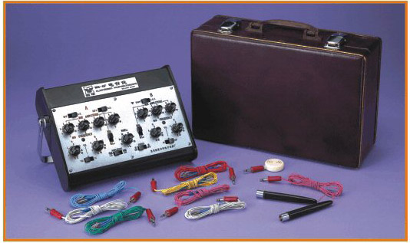
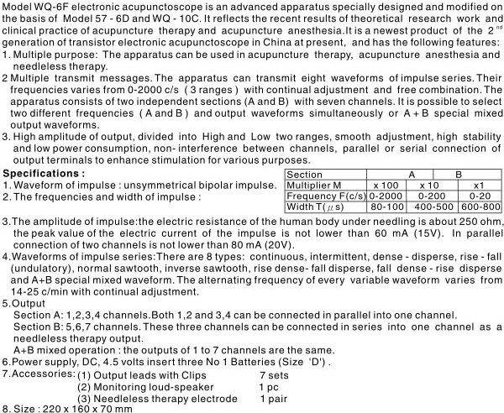
€ 255

